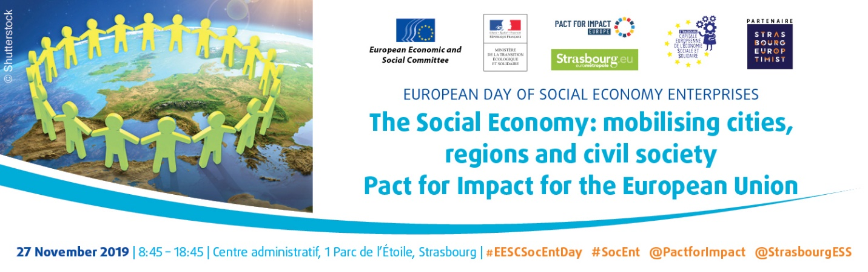

DRAFT PROGRAMME
8:00 | Registration and coffee
8:50 - 9:00 | Welcome speech  - Representative of the city of Strasbourg
9:00 - 9:45 | Opening  - President of the Eurometropole of Strasbourg  - Luca Jahier, President, European Economic and Social Committee  - Christophe Itier, France High Commissioner for ecological and solidary transition  - Representative of the Spanish government (tbc)
9:45 - 12:00 | Parallel participatory workshops  - The EU social market economy: which role for the Social Economy Enterprises?  - Pact for Impact: which commitments for Europe?  - The Social Economy as a driver to co-construct ecological transition in cities and regions: why is the European dimension essential?
12:00 - 14:00 | Lunch
14:00 - 16:00 | Courtroom debate for the future generations  Should social economy enterprises become the norm?
16:00 - 17:00 | EU institutional panel  - Representative of the Croatian Presidency of the Council of the EU (tbc)  - Representative of the European Parliament (tbc)  - Representative of the European Commission (tbc)  - Ariane Rodert, President of the Section for the Single Market, Production and Consumption, European Economic and Social Committee  - Representative of the Committee of the Regions (tbc)
17: 00 - 17:30 | Handing over of the Strasbourg Declaration to the new European Commission and the new European Parliament
17:30 - 17:45 | Presentation of the Strasbourg process on the European capital for social economy

 | SIDE EVENTS
17:45 - 19:00 | Side event on Social Economy in the Euromediterranean region  organised by Social Economy Europe
17:45 - 20:00 | Possibility to visit the part of the Strasbourg Christmas Market dedicated to social economy  https://noel.strasbourg.eu/marche-off

Participants can speak in English, French and Spanish and listen to English, French and Spanish

